FOR IMMEDIATE RELEASE
August 8, 2018

CONTACT
Juergen Barbusca, manager of communications
(702) 545-1004, juergen.barbusca@cox.com, #CoxCharities #CoxLasVegas

Cox Charities awards $95,000 to local nonprofits at annual ceremony

LAS VEGAS, August 8, 2018 - Cox Charities, the philanthropic arm of Cox Communications in Las Vegas, presented $95,000 in grants to 29 local nonprofit organizations on Wednesday, Aug. 8. Ten nonprofits received $5,000 each and the remaining 19 organizations received grants in amounts ranging from $1,500 to $3,000 at an annual grant distribution ceremony.

The awards were presented to a representative of each of the local 501(c)(3) nonprofit organizations listed below. The presentation was made at a bi-annual employee gathering led by senior leaders of the Cox Southwest Region. Approximately 800 of the Company’s just over 1,600 employees attended the festive awards program.

Cox Charities is an employee funded and managed workplace giving program begun in 2007. It has awarded more than $1.7 million in charitable grants to over 100 diverse nonprofit organizations/agencies that serve children/families, education/STEAM and diversity.

Cox Charities 2018 Grant Recipients
- Acing Autism, $2,500
- After School-All Stars, $3,000
- Andson Foundation, $5,000
- Boys Town Nevada, $2,657
- CASA Foundation, $2,500
- Communities in Schools of Nevada, $5,000
- Edward Kline Memorial Homeless Veterans Fund, $2,500
- Family & Child Treatment of Southern Nevada, $2,500
- Foster Kinship, $1,000
- Friends of the Las Vegas Metropolitan Police Foundation, $5,000
- Grant a Gift Autism Foundation, $2,500
- HELP of Southern Nevada, $1,500
- Junior Achievement of Southern Nevada, $2,500
- Las Vegas Clark County Library District Foundation, $2,500
- Las Vegas Philharmonic, $2,172
- Miracle Flights, $2,500
- Nathan Adelson Hospice Foundation, $2,500
- Nevada Child Seekers, $5,000
- Nevada Childhood Cancer Foundation, $5,000
- Nevada Diabetes Association for Children & Adults, $5,000
- Opportunity Village Foundation, $3,000
- Refuge for Women Las Vegas, $5,000
- Ronald McDonald House Charities of Greater Las Vegas, $5,000
- Street Teens, $2,000
- Serving our Kids Foundation, Inc., $5,000
- The Animal Foundation, $2,000
- The Gay and Lesbian Community Center of Southern Nevada, $5,000
- The Public Education Foundation (PEF), $3,000
- The Smith Center For The Performing Arts, $2,172

About Cox Charities
Cox Charities is the philanthropic giving arm of Cox Communications, Las Vegas. It is an employee-driven and resourced community giving initiative that provides annual competitive grants to nonprofit agencies in Southern Nevada. Since 2007, a rotating committee of Cox employees manages the workplace giving campaign, solicits grant applications and approves grant requests. The committee evaluates requests based on the organization’s mission, programming and written grant application. Cox Charities provides funding to initiatives that support the company’s philanthropic cornerstones of children/families, education/STEAM and diversity. Visit coxcharitieslv.com.

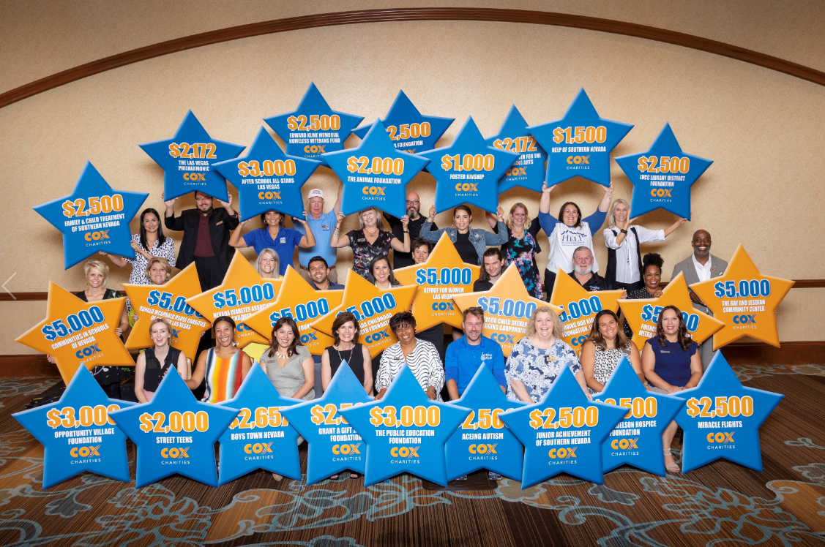

Photo caption:
Pictured are representatives of 29 local nonprofit organizations who shared $95,000 in grants from Cox Charities, the philanthropic arm of Cox Communications, Las Vegas.

###

